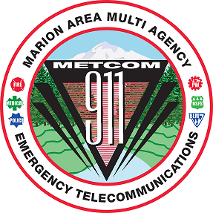
METCOM 9-1-1 GOVERNING BOARD MEETING
Date: May 28, 2025
Time: 10:00 a.m. – 11:30 a.m.
Location: METCOM, 1060 Mt. Hood Ave, Woodburn OR
ZOOM LINK:
https://us02web.zoom.us/j/83042926012?pwd=pqL3Ixfmi7xQQmQxHYzExDSMTh4cNS.1
Meeting ID: 830 4292 6012 Passcode: 911301
AGENDA

Call to Order – Mark Daniel

Board Meeting Minutes Approval
(April 7, 2025) – Mark Daniel Action Item

Budget Adoption Action Item
(Damian Flowers, John Thompson)

Marion County Radio Project Update
(Brian Nicholas, Patrick Hoover)

Staffing Update
(John Thompson)

Open Agenda Update

Future Meetings for Calendar Year 2025 (all start at 1000)
TBD

