**METCOM 9-1-1**

**Governing Board Meeting Minutes**

November 19, 2024

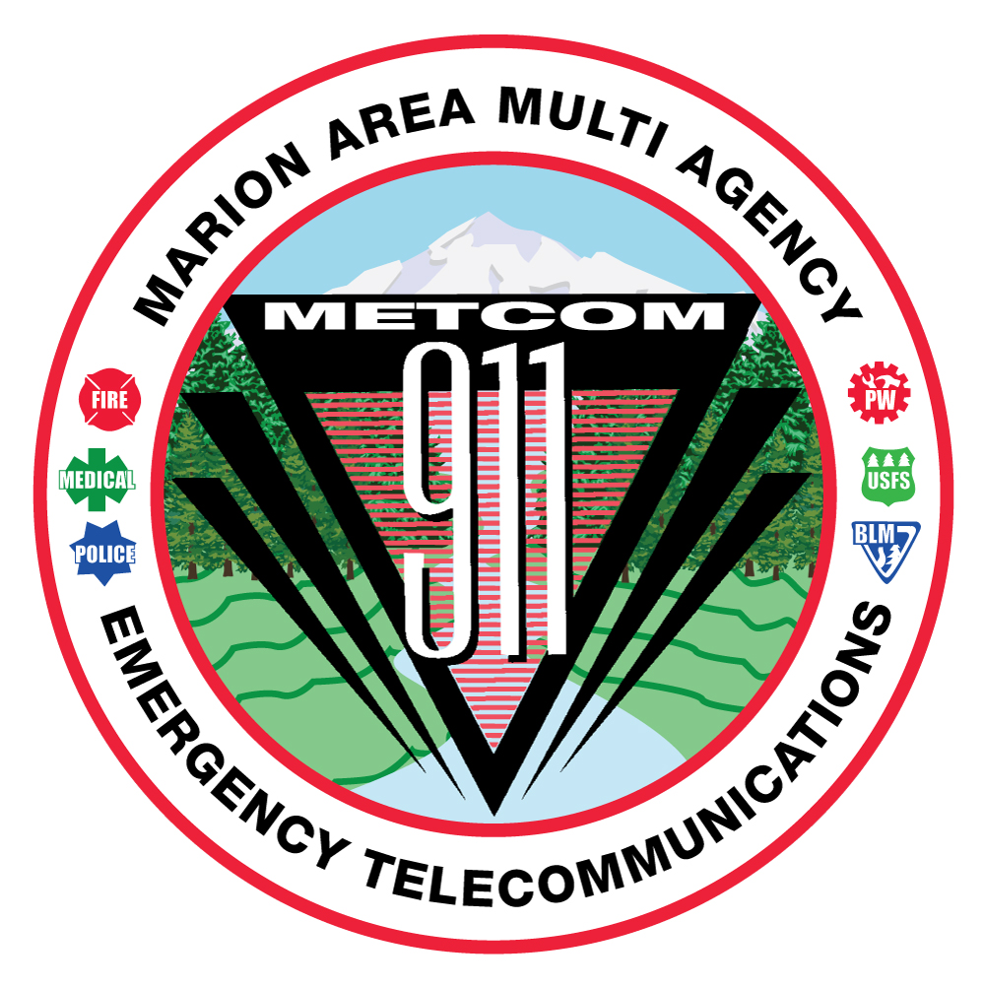

**Members in Attendance:** **Other in Attendance**

Jason Millican JP Fogarty Santiam Ambulance

Don Parise

Levi Eckhardt

Brett Swenson

Rob Garrison

Jordan Donat

Jim Trierweiler **METCOM**

Bill Miles Tracy Arnett

Keith Veit John Thompson

Sherry Bensema

Joe Budge

Alan Hume

Jay Alley

Todd Engstrom

Mark Gaither

Mark Daniel

**METCOM regular Governing Board meeting called to order at 10:05 AM with a quorum met by members present and via Zoom.**

The Board meeting was opened by Chief Mark Daniel.

The September 17, 2024 Board meeting minutes were provided to Board members via email and available in hard copy form or by request at the meeting. Members asked if there were any changes to the minutes provided. None were voiced. The motion to accept the minutes were made as follows:

* Sherry Bensema made a motion to accept the September 17th, 2024 Board Meeting minutes.
* Second by Levi Eckhardt
* Discussion: None. Motion passed, no opposition.

**Budget Committee**

John Thompson asked for board members to volunteer to form the Budget Committee for the upcoming fiscal year 2025-2026.

Alan Hume asked if the ORS 190 requires the User Fee Committee to be the same members to make up the Budget Committee. After the board meeting, John Thompson reviewed the ORS 190 agreement after the meeting and didn’t find language stating the committees will be made up of the same members.

Committee members are as follows: Michael Kahrmann, Damian Flowers, Don Taylor, Mark Daniel, Sherry Bensema, Levi Eckhardt, Dan Mullen. We are waiting for the annual audit report to be completed to begin the committee’s work.

**METCOM Director Position:**

Mark Daniel shared with the board a letter of interest for John Thompson to assume the Director position. Mark stated it’s a great idea and there wouldn’t be a need to go to the outside hiring process. Mark asked to move forward with Board support to negotiate a contract with John Thompson to become the Director of METCOM.

Alan Hume inquired if a Public Agency is required to open a hiring process or if it is legal to appoint if we have qualified people.

* Alan Hume made a motion to seek legal counsel on the legality of appointing John to the position of Director.
* Second by Mark Daniel
* Discussion: None. Motion passed, no opposition.

John Thompson will follow up with METCOM’s legal counsel to ensure the position can be appointed without commencing a hiring process.

**User Fee Committee:**

Levi Eckhardt stated there is a committee meeting scheduled next week to discuss the data and numbers and how they look. The committee is discussing leaving the 59/41 split as is or completely change to a base fee that everyone would pay based on population and call volume. Fire is looking at using a 3 year call average, and it’s not as clear on the police side as of yet.

John Thompson has reached out to Dispatch Centers across the country to seek out fee formulas and is awaiting results.

**Dispatch Console Replacement:**

John Thompson shared the phone project at the Stayton back-up center must be completed for METCOM to move forward with the furniture replacement. The phone project is expected to be completed the week of January 13th, 2025 and the console replacement at METCOM will likely follow a couple weeks later in February.

**Recruitment Update:**

John Thompson provided the following recruitment updates for METCOM.

* One employee in training was recently terminated for failing to meet standards
* METCOM is currently at 11 of 19 fully trained full-time positions
* 3 additional employees in various phases of training
* 2 applicants in the pre-employment psych phase
* 3 more applicants moved to backgrounds
* 2 applicants remaining for the open Supervisor position, completing testing and expect interviews in December

**Marion County Radio Project:**

John Thompson and the METCOM Executive Board met with Sheriff Hunter and Brian Nicholas. Brian presented new numbers and costs across the board for subscriber fees and a new, unexpected cost titled “proportional share.” Proportional share is based off the number of radios needed, the cost for the radio based on the contract the County has with Tait, and costs for installation. The proportional share cost at this point is estimated to be $2.2M.

Brian Nicholas presented multiple scenarios with subscriber fees changing dependent upon the number of agencies joining the system, to include Marion County Fire District and Aurora Fire District. Mark Daniel told Brian Nicholas that no way his agency can cover the new fees and how all taxpayers could fund the entire system for METCOM users and the Sheriff’s Office, but to surprise us with this latest fee is not doable.

Mark Daniel stated there is concern the capacity of the system may not be sufficient for the number of users. Mark is concerned that during large incidents with responders all over the area simply by turning on their radios to hear what is going on. Any radio turned on will take space on the system, even if they aren’t talking. This has been an issue with other similar radio systems during large scale events.

Marion County is moving forward with a 3 channel system regardless of what METCOM chooses to do. Further discussion is needed if METCOM will move forward with joining Marion County’s system, and if not, what that will look like.

Discussion continued regarding the potential for looking at the VHF Simulcast system that was designed several years ago, in the event the project doesn’t work out with the County.

Q: Jason Millican - What is the benefit of a simulcast system?

A: The radio system would function similar to what we have in place today, it would provide updated equipment across the system. This would also allow agencies to talk on the radio across the county as needed.

Q: Todd Engstrom - How would simulcast improve reception in our town.

A: If the same sites are used and nothing further added, it may not necessarily increase coverage. We’d need to look at the system design and propagation studies more thoroughly that were worked up when we were moving with the project previously.

Levi Eckhardt – Linn County just built a VHF Simulcast system and I can sit in my office and talk to Linn County from my portable. It has helped boost the system to be able to talk.

There was discussion regarding the funding provided from Senator Girod and if that money would come back to METCOM if we do not join the County system. Marion County accepted the monies on behalf of METCOM.

Further discussion regarding available frequencies. Jim Trierweiler mentioned Mt. Angel Fire currently owns 5 frequencies and only use 1, and would be willing to provide frequencies to the project.

The Board discussed and recommended the METCOM Executive Board meet with the Board of Commissioners again to discuss the project and funding issues. Additionally, John Thompson will engage with Day Wireless to discuss the previous VHF Simulcast project and request updated costs to build it.

Jim Trierweiler asked about the First Net meeting that occurred some time ago, regarding the potential of using a First Net console and an app from cell phones. With cell phone reception increasing more and more, it’s been better than radio coverage. John was only aware of a meeting or presentation occurring and will look in to records to try and get more information.

**General Updates:**

**Open Discussion:**

**Future Meeting Dates:**

All meeting will start at 1000 hours.

**February 12, 2025** (Woodburn PD)

**March 18, 2025** (Location TBD)

**April 8, 2025** (Stayton Fire District)

**May 28, 2025** (Location TBD)

Chair Mark Daniel closed the meeting and adjourned at 1123.