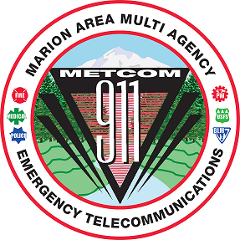
METCOM 9-1-1 GOVERNING BOARD MEETING
Date: September 17, 2024
Time: 10:00 a.m. – 11:30 a.m.
Location: METCOM, 1060 Mt. Hood Ave, Woodburn OR
ZOOM LINK:
https://us02web.zoom.us/j/84958616965?pwd=br7YD2MW0rwd7DTQJZsxLt85w5LuZk.1
Meeting ID: 849 5861 6965 Passcode: 481905
AGENDA

Call to Order – Mark Daniel
Board Meeting Minutes Approval
(July 2, 2024) – Mark Daniel Action Item

Interim Director Pay – Mark Daniel Action Item

User Fee Committee Update

Dispatch Console Project Update

Back-up Center Phone Project Update

Annual Audit Update

Staffing Update

Open Agenda Update

Future Meetings for Calendar Year 2024 (all start at 1000)

- November 19, 2024 @TBD

