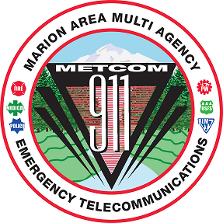
METCOM 9-1-1 GOVERNING BOARD MEETING
Date: September 3, 2025
Time: 10:00 a.m. – 12:00 p.m.
Location: METCOM, 1060 Mt. Hood Ave, Woodburn OR
https://us02web.zoom.us/j/87638147777?pwd=T6NW0BcOUDHuQyN9yzaRxuVSV0vRo8.1 Meeting ID: 876 3814 7777 Passcode: 192449
AGENDA

Call to Order – Mark Daniel

Board Meeting Minutes Approval Action Item
(May 28, 2025) – Mark Daniel

Marion County Radio Project Update
(Brian Nicholas)

PSAP Consolidation Discussion Update
(John Thompson, Mark Daniel)

Staffing Update
(John Thompson)

Open Agenda

Future Meetings for Calendar Year 2025 (all start at 1000)
TBD

